Data and Metadata Profile:

Washington State’s Electric Vehicle Population Data

Marissa Fischer

LIS 545: Data Curation I: Fundamentals

January 26, 2024

The [Electric Vehicle Population Data](https://data.wa.gov/d/f6w7-q2d2), published by the Washington State Department of Licensing, is a public dataset consisting of data on registered vehicles in Washington that are Battery Electric Vehicles (BEVs) or Plug-in Hybrid Electric Vehicles (PHEVs). This dataset was created in April 2019 and was updated as recently as last week. Despite being consistently updated by Washington DOL, there is no indication of how far back registration data is being compiled in this dataset.

Key stakeholders for this dataset include Washington Department of Licensing and Washington Department of Transportation, as well as the departments on the federal level, for tracking vehicle registration trends. This data is also relevant for the state and federal Departments of Ecology or the EPA to help monitor the rate of transition to “clean fuel” that residents in certain areas are making.

There are four data files listed on Data.gov for this particular dataset, in CSV, RDF, JSON, and XML formats, and all have the option to download them directly from the page. There is also a link to the Data.WA site that initially published this dataset and gives more information, including an easily read table version of the dataset that does not require any downloads (see Fig. 1 below). The .csv file will open in Notepad if Excel is not available on your computer and both the JSON and XML files will open in an internet browser window. The RDF file was able to be downloaded, but it requires either the Firefox internet browser or additional programs to open it. There are no listed restrictions for this dataset and both Data.gov and Data.WA indicate that it is publicly available and does not contain any federal information that would be subject to more extensive restrictions.

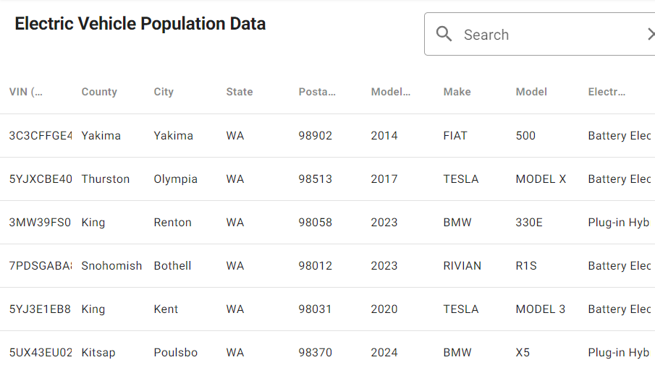

Fig. 1: Snapshot of dataset table provided on Data.WA

Available metadata on the dataset includes created date, updated date, publisher and maintainer information, public access level, schema version, licensing information, links for cataloging and context, etc. All of this metadata is mapped out in a table on Data.gov and Data.WA, but does not exist within the downloadable files. Further context on the data is given in the dataset files through attributes, such as VIN, County, Make, Model, etc., for the records.

While the dataset seems very straightforward, no context is given for what the data is used for or by whom, other than Washington DOL. Some metadata components, e.g., Harvest Source, are detailed enough for data scientists and curators, but would not be as easily understood by general users who were browsing the dataset for various referencing reasons. The metadata is structured according to the Project Open Data Metadata Schema v1.1. The schema is linked in the metadata of the dataset so that it can be easily referenced or replicated.

The current data could be improved by including the most recent date of registration, helping to show the scope of how electric cars are increasing in prevalence in the state and could help show movements patterns of BEV and PHEV owners if the registration was not renewed. Including the registration date would also allow other states to compare the dataset with their own data based on the latest year of registration rather than having to rely on the model year of the car. This would remove any uncertainty of if the car was registered in Washington the year it was made or if it was moved to Washington or was bought as a used car years later. The data or metadata for this dataset also does not indicate what updates are being made, beyond adding new records of registrations. Indicating in the description of the dataset if inactive registrations are being left in or removed would help users better understand what sort of historical data is being retained and increase the potential for drawing any conclusions from the data.

On the Data.WA site page for this dataset, there are other datasets listed that were made by referencing the Electric Vehicle Population Data. These datasets include ones, such as Electric Vehicle Population Maps, Most Common Registered Electric Vehicle Models, etc., that help expand on and try to make sense of the patterns in the original dataset. Additional publications that reference Data.WA’s dataset include briefs and grant documentation from Washington Department of Commerce, Washington State Department of Transportation, and the Washington Utilities and Transportation Commission. These publications use the dataset to forecast clean fuel trends (WDOC 2022), establish a zero-emission vehicle infrastructure for the State of Washington (WSDOT 2023), and identify trends that could affect Washington’s energy supply (UTC 2023). There was also a published article that uses the dataset as a repository for an MIT study on energy resources for the United States (Haider, Xu, Yang 2023). All of these publications were found through searching the URL of the dataset or the dataset name in Google. No results were found through Google Scholar or any UW databases, such as EBSCO or Environment Complete.

As a whole, Washington’s Electric Vehicle Population Data is a good dataset to use for creating visualizations and connecting with other data to see greater trends. With some improvements, such as including more context on historical data or the date of the record, this dataset could be applied to a broader selection of studies conducted by other states on the existence of BEV and PHEV registrations in their regions. It is surprising that this dataset has not been leveraged more by the State of Washington, beyond the publications that were referenced previously, as there is extensive data in this dataset that could bolster an increase in support for electric vehicles and their owners at the state level.

**References**

Data.gov (2024, January 19). *Electric Vehicle Population Data: Data.gov: United States General*

*Services Administration.* <https://catalog.data.gov/dataset/electric-vehicle-population-data>

Haider, R., Xu, Y., & Yang, W. (2023, June). Towards closing the data gap: A project-driven

distributed energy resource dataset for the US Grid. In *Companion Proceedings of the*

*14th ACM International Conference on Future Energy Systems* (pp. 52-58).

Washington Department of Commerce (2022, September 23). *Clean Fuel Forecast:*

*Ecology.WA.gov: State of Washington.* [https://ecology.wa.gov/getattachment/4ada812c-](https://ecology.wa.gov/getattachment/4ada812c-a8b5-41c5-bcb8-3a724f8e5b27/20220923CleanFuelForecastRpt.pdf)

[a8b5-41c5-bcb8-3a724f8e5b27/20220923CleanFuelForecastRpt.pdf](https://ecology.wa.gov/getattachment/4ada812c-a8b5-41c5-bcb8-3a724f8e5b27/20220923CleanFuelForecastRpt.pdf)

Washington State Department of Licensing (2024, January 16). *Electric Vehicle Population*

*Data: Data.WA: State of Washington*. <https://data.wa.gov/d/f6w7-q2d2>

Washington State Department of Transportation (2023, March 9). *Zero-Emission Vehicle*

*Infrastructure Partnership Program, 23-25 Grant Guidelines: WSDOT.WA: State of Washington*. [https://wsdot.wa.gov/sites/default/files/2023-03/WSDOT-ZEVIP-Grant-](https://wsdot.wa.gov/sites/default/files/2023-03/WSDOT-ZEVIP-Grant-Webinar-Slides.pdf)

[Webinar-Slides.pdf](https://wsdot.wa.gov/sites/default/files/2023-03/WSDOT-ZEVIP-Grant-Webinar-Slides.pdf)

Utilities and Transportation Commission (2023, February 7). *Issue Brief #6, The Mobility*

*Transition: UTC.WA: State of Washington.* [https://www.utc.wa.gov/sites/default/files/](https://www.utc.wa.gov/sites/default/files/2023-02/Issue%20Brief%20%236%20-%20The%20Mobility%20Transition.pdf)

[2023-02/Issue%20Brief%20%236%20-%20The%20Mobility%20Transition.pdf](https://www.utc.wa.gov/sites/default/files/2023-02/Issue%20Brief%20%236%20-%20The%20Mobility%20Transition.pdf)